Assignment 2: Advanced CRUD Operations

Swiggy Restaurant Database (restaurants.json)

Link for Dataset: https://drive.google.com/file/d/1RE71Oji2Rr-ZexhX0QCqe-C4epTEZDIY/view?usp=drive_link

Scenario 1 — Premium Choice Promotion
Topics: Comparison Operators, Logical Operators ($and, $or)
Swiggy's marketing team is launching a "Premium Choice" promotion. A restaurant qualifies if it meets EITHER of two different quality bars: (a) rating greater than 4.3 AND delivery fee under
₹40, OR (b) it belongs to the "Biryani" category AND delivers in under 40 minutes. Write a single query using $and nested inside $or to find these restaurants. Display only name, category, rating, deliveryFee, and deliveryTime, sorted by rating in descending order.

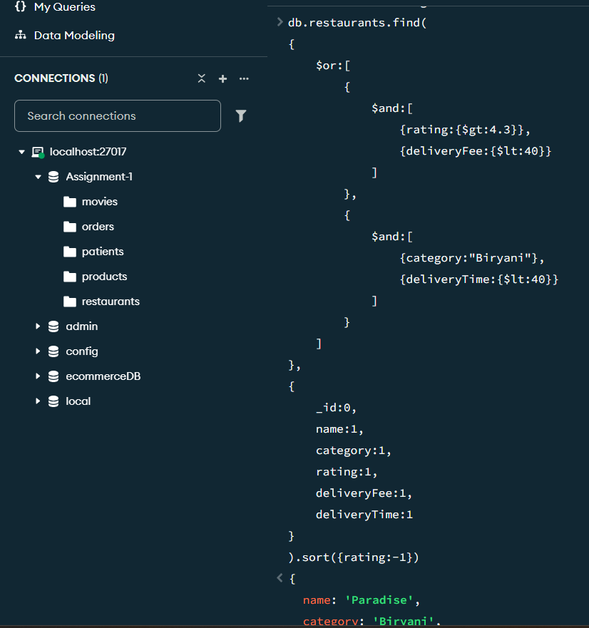

Scenario 2 — Signature Dishes Tagging
Topics: Element Operators ($exists, $type), Update Documents ($set)
Before adding new data, the tech team wants a data-integrity check. Write a query using $exists and $type to confirm that every restaurant document has a category field stored as a string. Once confirmed, add a new array field signatureDishes to each restaurant using $set: Paradise → ["Biryani","Kebabs"], Dominos → ["Pizza","Garlic Bread"], Mehfil → ["Biryani","Haleem"], KFC → ["Fried Chicken","Popcorn Chicken"], Burger King → ["Whopper","Fries"], Subway → ["Sub Sandwich","Salad Bowl"].
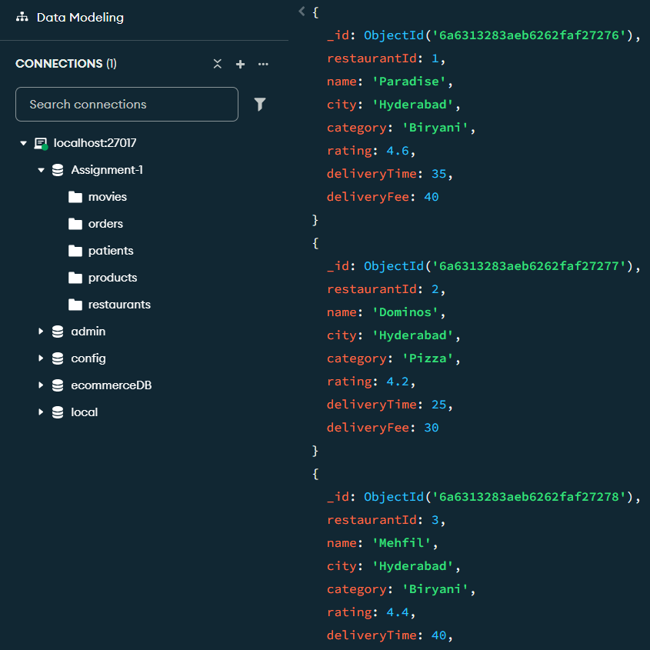
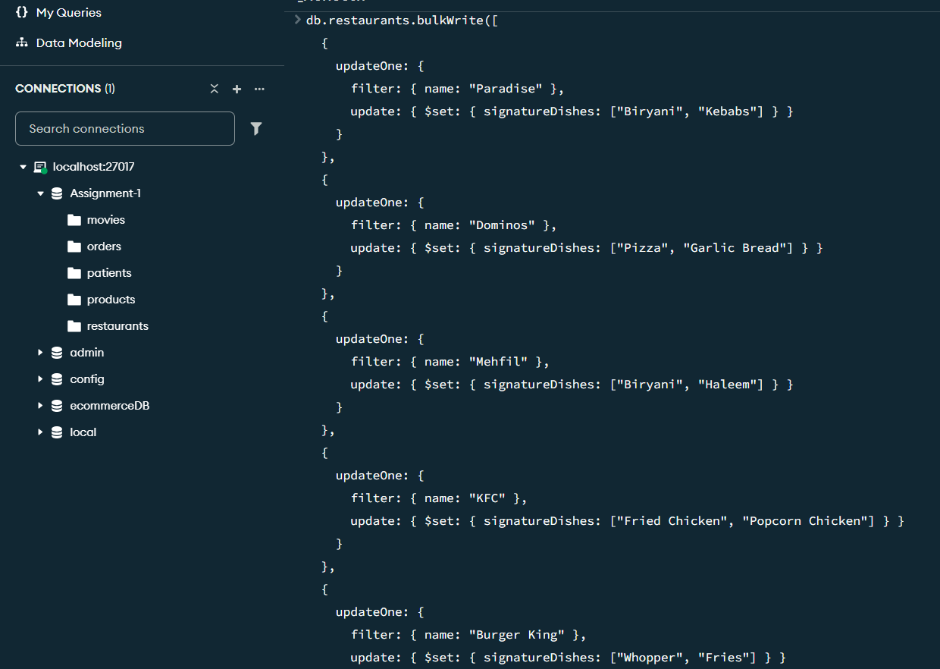
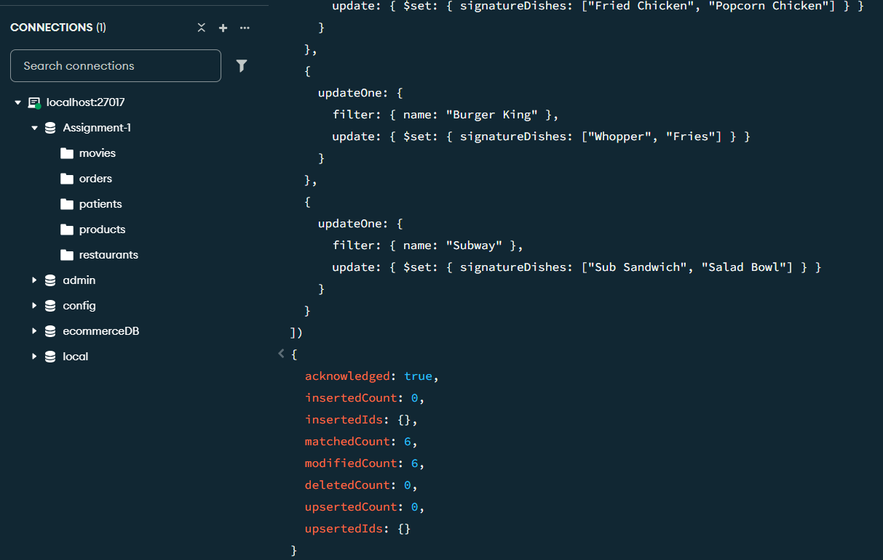
Scenario 3 — Discontinuing Underperformers + Price Hike
Topics: Logical Operators ($nor), Delete Documents, Update Documents ($inc)
Swiggy wants to discontinue restaurants that are neither highly rated (rating ≥ 4.5) NOR fast (delivery time ≤ 25 minutes). Use $nor to find and display these restaurants first, then permanently remove them with deleteMany(). Afterwards, apply a ₹5 delivery-fee hike using $inc to every surviving restaurant whose current fee is still below ₹40.

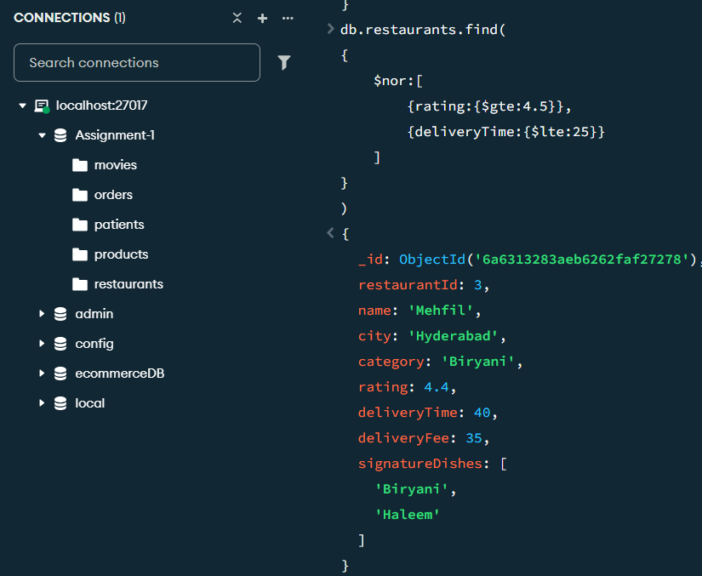

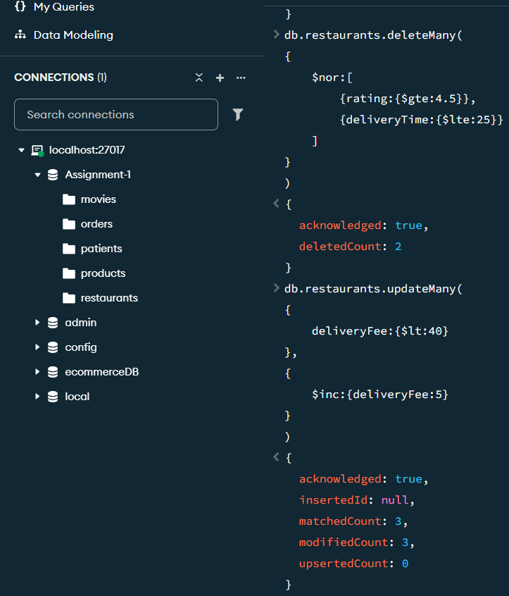

Scenario 4 — Biryani Lovers & Menu Variety
Topics: Reading Arrays ($size, array equality), Comparison & Logical Operators
Using the signatureDishes array built in Scenario 2, and working only against the restaurants that survived the Scenario 3 cleanup, find every restaurant whose signatureDishes array contains "Biryani" OR has exactly 2 dishes listed, combined with the condition that its rating is greater than 4.0.
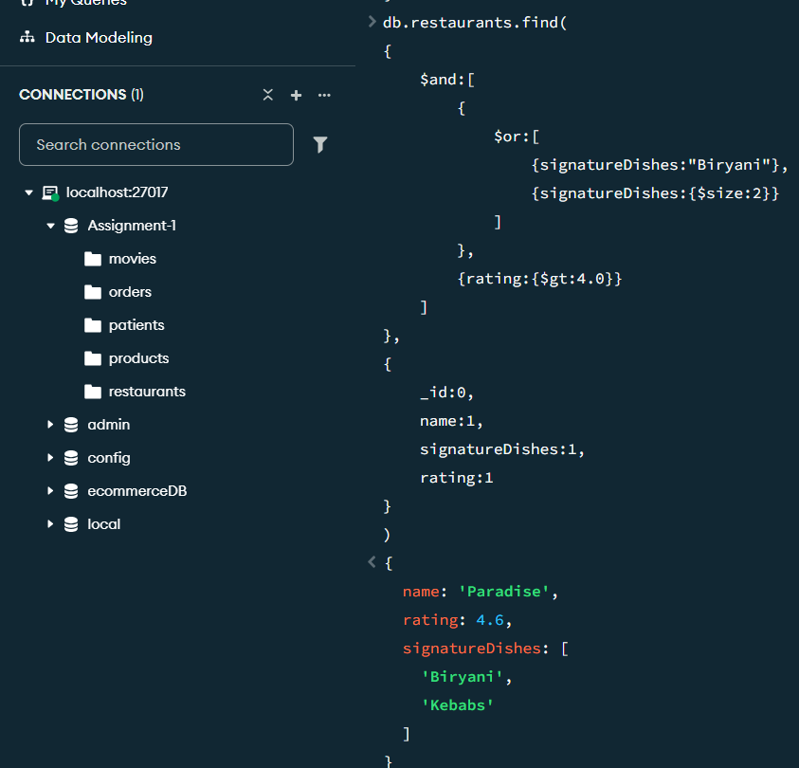

Scenario 5 — Weekend Campaign & Service Tags
Topics: Updating Arrays ($push, $each, $pull, $addToSet)
For the weekend campaign, use $push with $each to add two new items — "Weekend Special Thali" and "Combo Meal" — to the signatureDishes array of every restaurant with rating greater than 4.4. Since Burger King is discontinuing its fries, use $pull to remove "Fries" from its signatureDishes array. Finally, give every restaurant a new services array field using $addToSet containing "Contactless Delivery", written so that re-running the update does not create a duplicate entry.
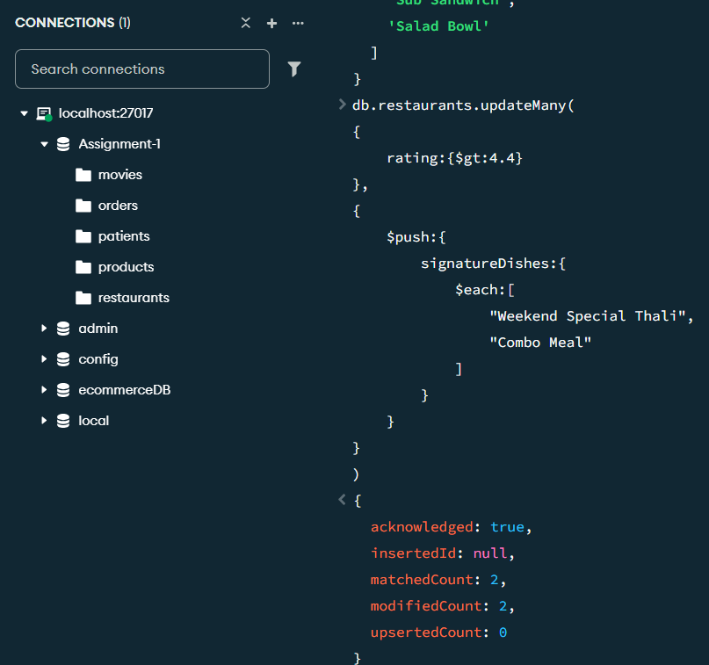

Hospital Management System (patients.json) Link for Dataset:
https://drive.google.com/file/d/1m5C6U7-1P6OMTWVcUbhQoqrMnjl86T8M/view?usp=drive_link

Scenario 1 — Priority Case Review
Topics: Comparison Operators, Logical Operators ($and, $or, $in)
Hospital administration wants a priority list of patients who are either elderly and high-billed (age greater than 40 AND bill greater than ₹10,000) OR diagnosed with a critical condition (disease is "Heart Disease" or "Covid"). Using nested $and inside $or, find these patients. Project name, age, disease, and bill, sorted by bill descending.

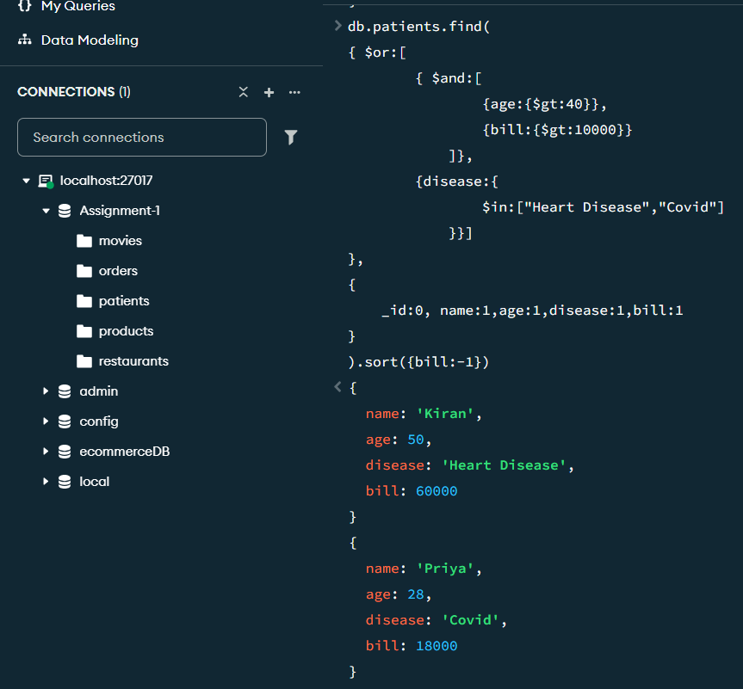

Scenario 2 — Allergy Records & Data Check
Topics: Element Operators ($exists, $type), Update Documents ($set)
Before extending the schema, confirm using $exists and $type that every patient document has a doctor field stored as a string. Then add an allergies array field to every patient using $set — some patients have no known allergies, represented as an empty array: Anita → ["Penicillin"], Rahul → [], Priya → ["Dust","Pollen"], Kiran → ["Aspirin"], Sneha → [], Ajay → ["Peanuts"].
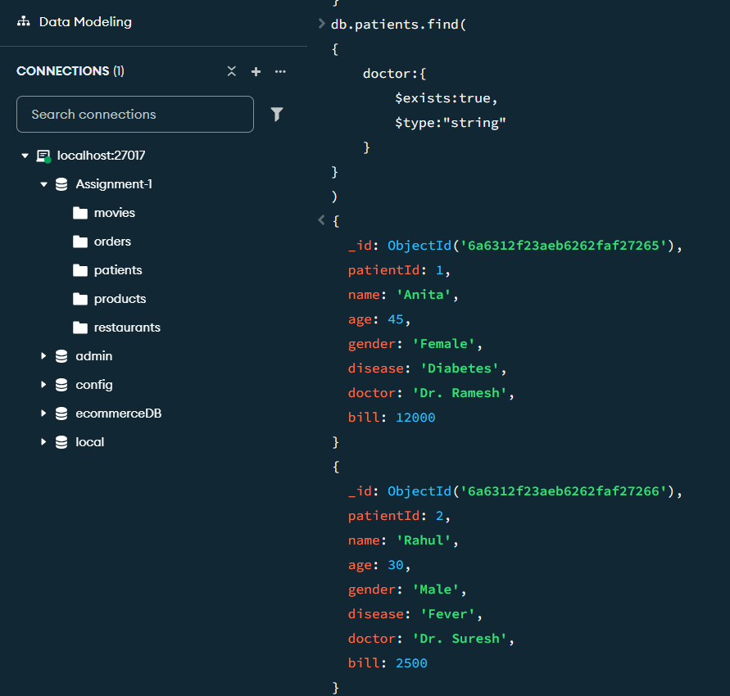
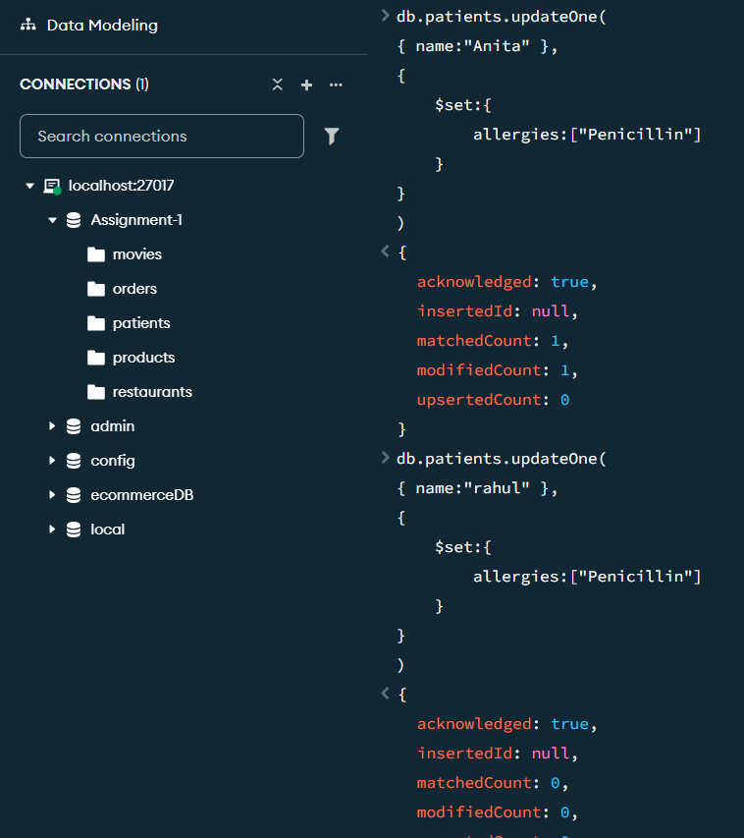

Scenario 3 — Discharge Cleanup & Admin Fee
Topics: Logical Operators ($nor), Delete Documents, Update Documents ($inc, $ne)
The hospital wants to purge closed, low-cost outpatient visits — records that are neither senior (age ≥ 45) NOR high-bill (bill ≥ ₹10,000) — using $nor. Find and delete these records. Then, for every remaining patient whose disease is not "Fever", apply an administrative fee by incrementing bill by ₹500 using $inc.

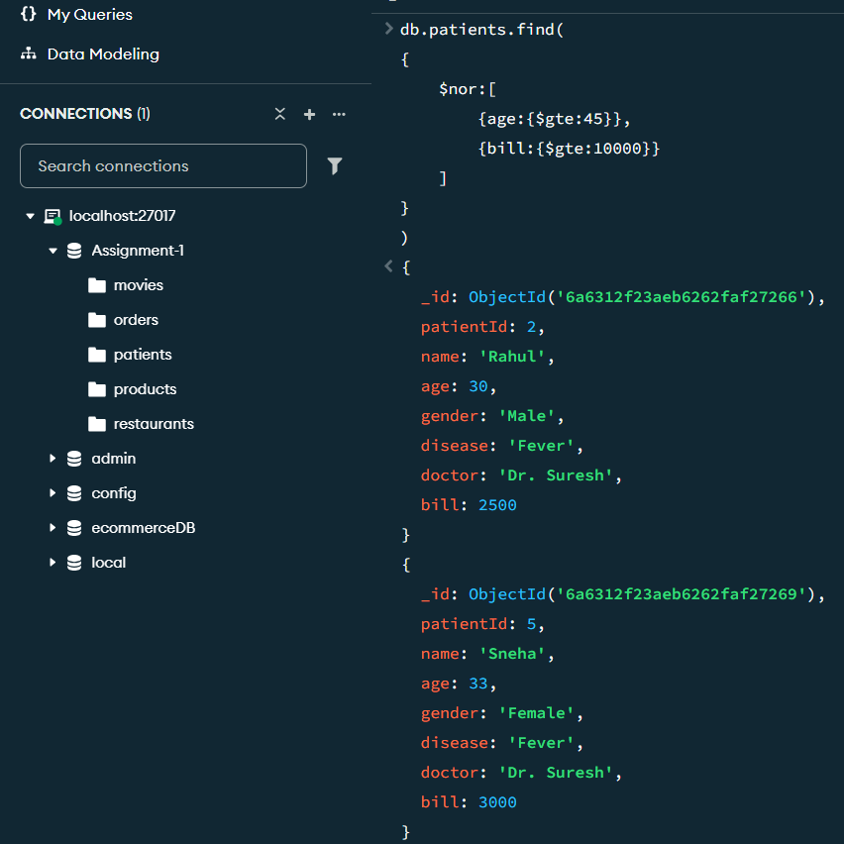
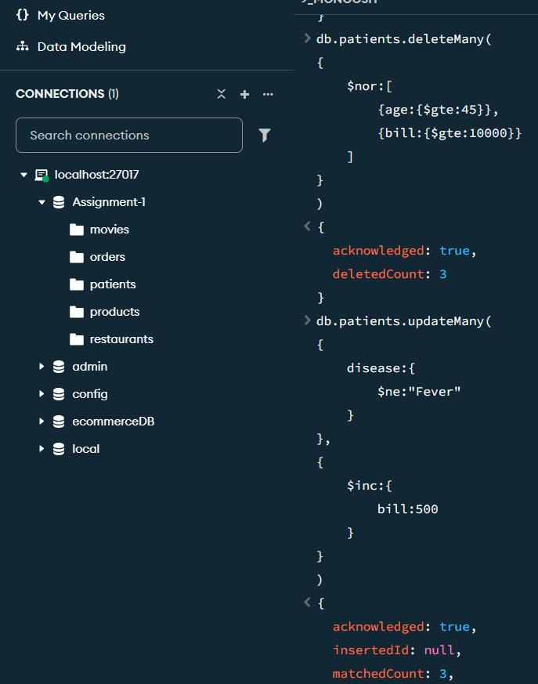

Scenario 4 — Allergy Alert List
Topics: Reading Arrays, Element Operators ($exists, $ne)
Using the allergies array from Scenario 2, and working only against the patients who survived the Scenario 3 cleanup, find every patient who has at least one recorded allergy — i.e., the array field exists and is not empty.
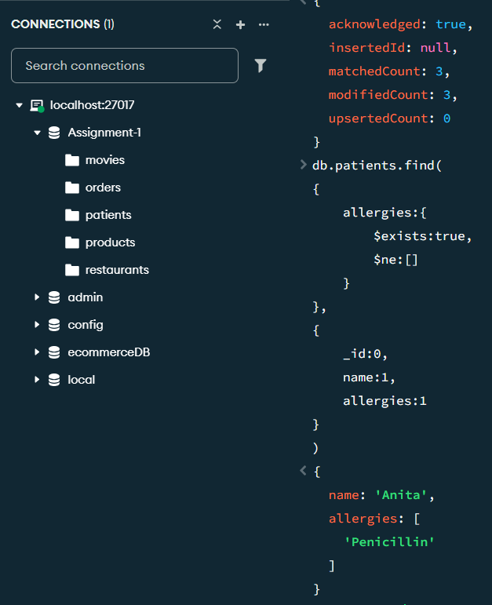

Scenario 5 — Updating the Allergy Protocol
Topics: Updating Arrays ($push, $addToSet, $pull, $pop)
A new case reveals Kiran is also allergic to Latex — use $push to add it to his allergies array. Priya's chart already lists "Dust", but a nurse re-enters it by mistake — use $addToSet to add "Dust" again and confirm no duplicate appears. Aspirin-based tracking is being discontinued for Kiran's case — use $pull to remove "Aspirin" from his array. Finally, Anita's oldest allergy entry needs to be retired — use $pop to remove the first element of her allergies array.

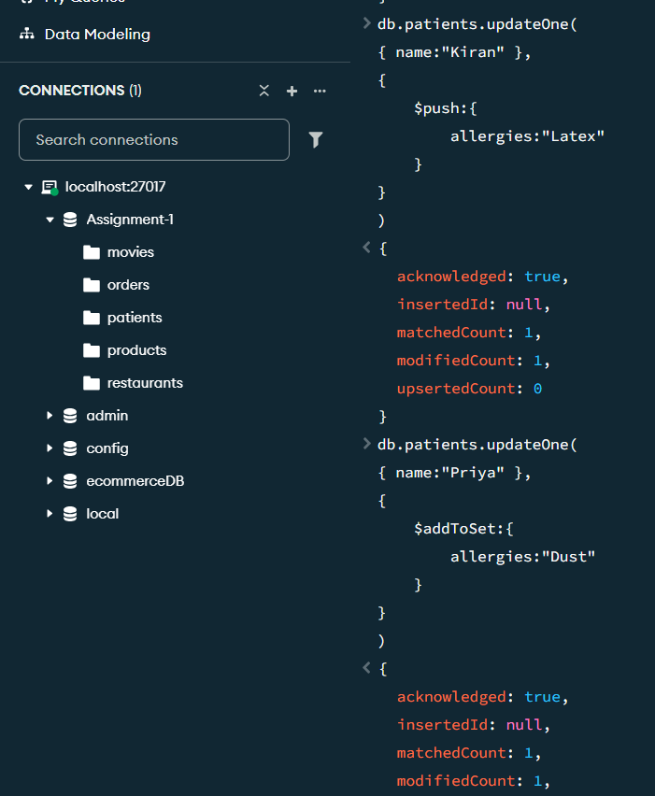
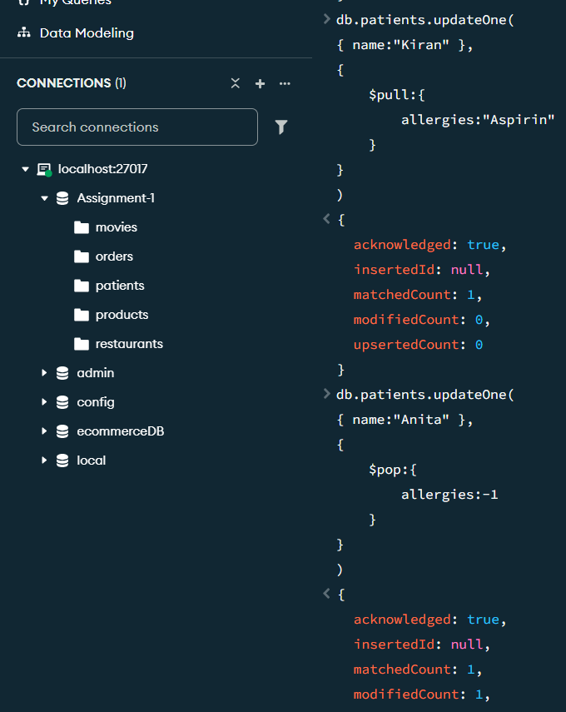

Netflix Movie Database (movies.json)

Link for dataset: https://drive.google.com/file/d/19FiXqDuK48k4jx_1hHJBMVRs03JO3_hS/view?usp=sharing

Scenario 1 — Trending Now Watchlist
Topics: Comparison Operators, Logical Operators ($and, $or)
The content team wants a combined "Trending Now" list: critically acclaimed English movies (language = "English" AND rating > 8.5) plus recent action blockbusters (genre = "Action" AND year ≥ 2022). Use $or with nested $and. Display title, genre, language, year, and rating, sorted by rating descending.
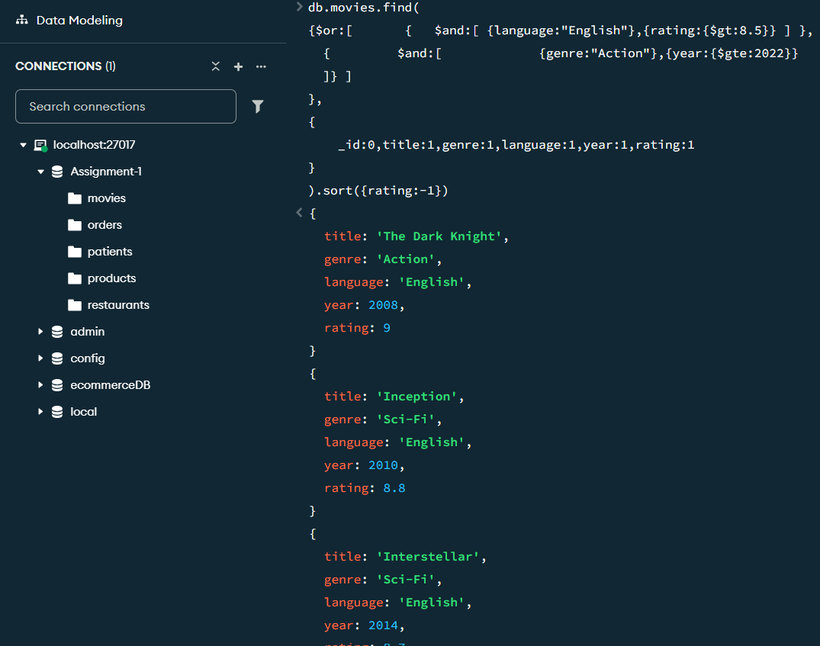

Scenario 2 — Cast Data Verification & Tagging
Topics: Element Operators ($exists, $type), Update Documents ($set)
Confirm using $exists and $type that every movie document stores its rating as a numeric (double) field. Then add a cast array field to each movie using $set, listing two lead actor names per film (fictional placeholder names are fine — this is for practicing array queries, not a factual cast record).
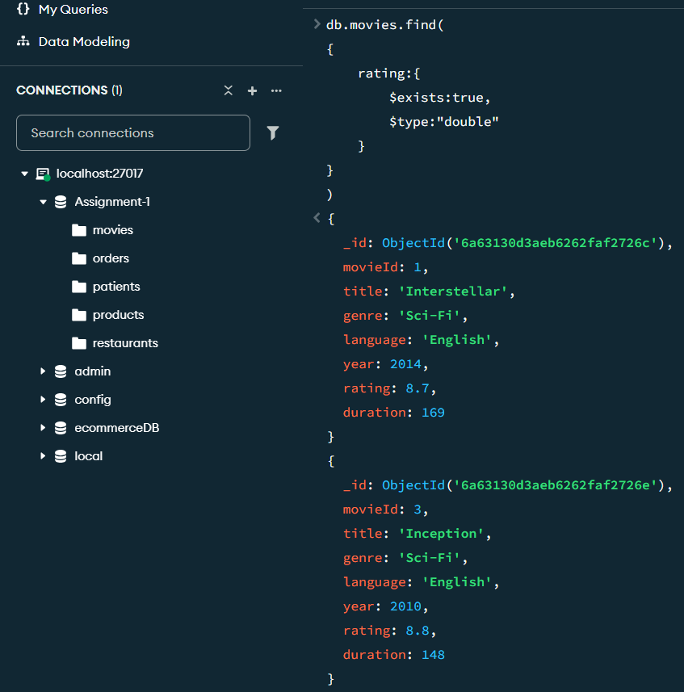
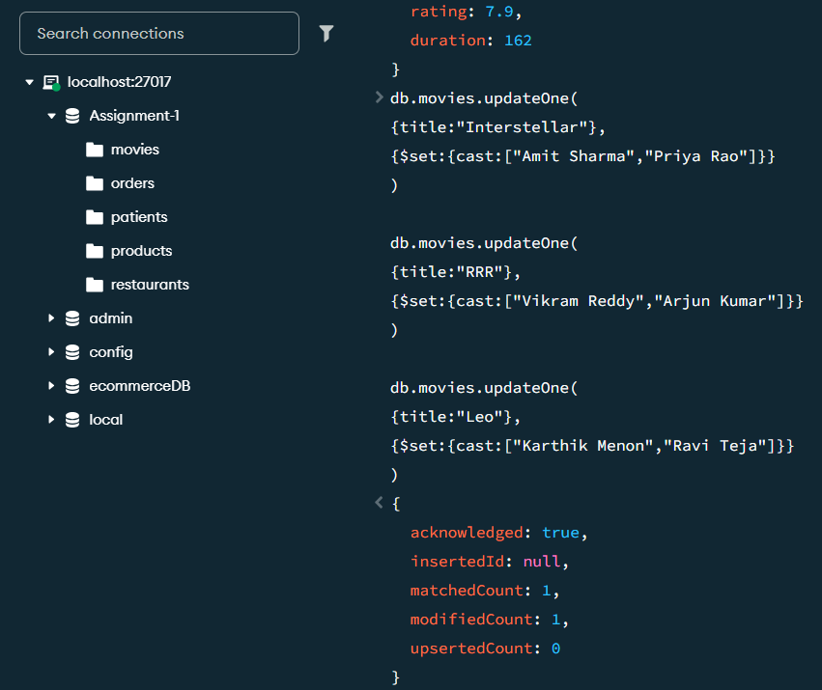

Scenario 3 — Catalog Cleanup & Extended Cuts
Topics: Logical Operators ($nor), Delete Documents, Update Documents ($inc)
The platform is retiring titles that are neither highly rated (rating ≥ 8.4) NOR recent (year ≥ 2022), using $nor. Find and delete these titles. Then, for the movies that remain and belong to the "Sci-Fi" genre, increase duration by 5 minutes using $inc to reflect newly restored extended cuts.
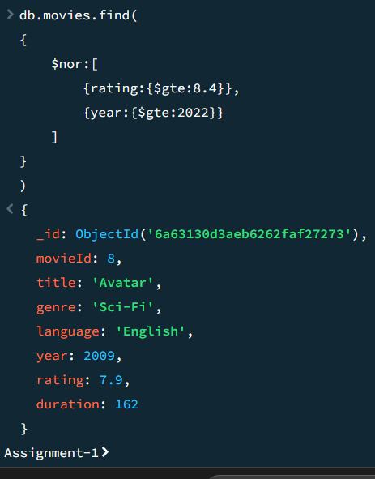

Scenario 4 — Cast-Based Discovery
Topics: Reading Arrays (array element match), Comparison & Logical Operators
Using the cast arrays from Scenario 2, find every Action-genre movie with a rating above 8.0 whose cast array contains "Vikram Reddy", combining an array match with comparison and logical operators.

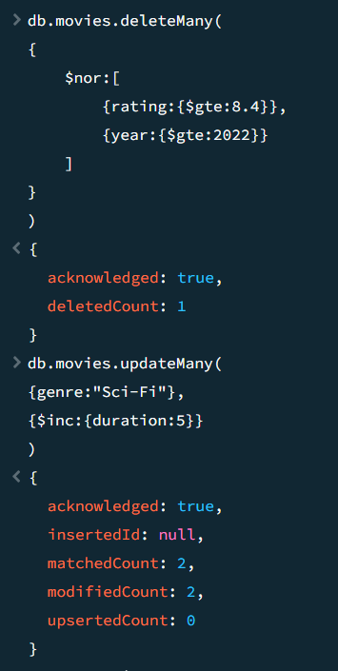
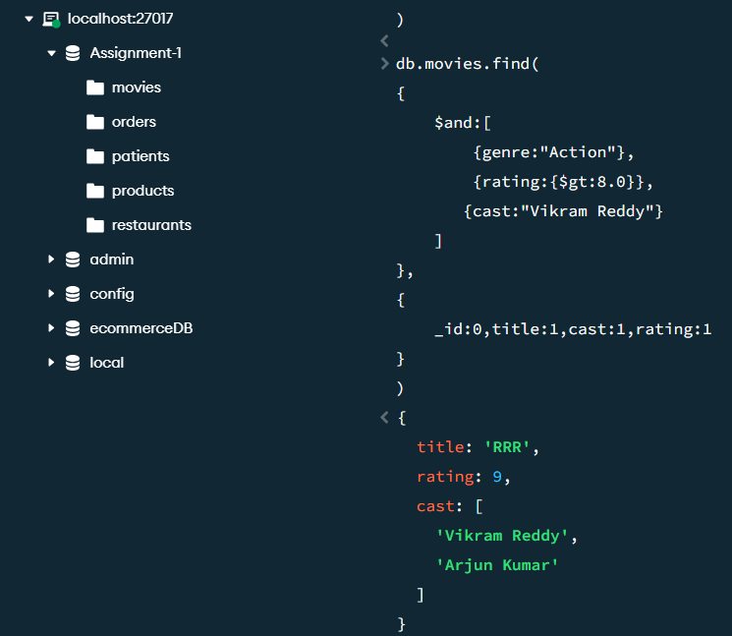

Scenario 5 — Cast Changes & Crew Updates
Topics: Updating Arrays ($push, $each, $pull, $addToSet)
RRR is getting a special re-release with two additional cast members, "Divya Nair" and "Sanjay Rao" — use $push with $each to add them to its cast array. Leo's original cast listing needs correcting since "Karthik Menon" has dropped out of the project — use $pull to remove that name. Finally, add a directors array field to every movie using $addToSet, written so re-running the update never creates duplicate director entries.
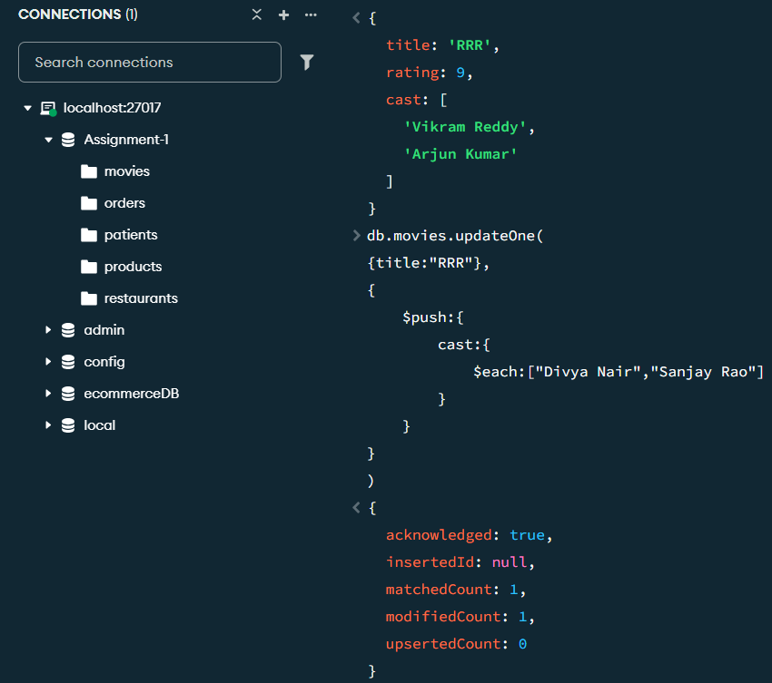

Online Food Delivery System (restaurant_orders.json)

Link for Dataset: https://drive.google.com/file/d/17yvfIJjWVzMHhk2MEj4c_k74E1vrB0Vr/view?usp=sharing

Scenario 1 — High-Value & Cancelled Orders Report
Topics: Comparison Operators, Logical Operators ($and, $or)
The finance team wants a combined report of orders that are either high-value Hyderabad deliveries (city = "Hyderabad" AND amount > ₹700) OR any cancelled order regardless of city or amount (status = "Cancelled"). Use $or with a nested $and, sorted by amount descending.
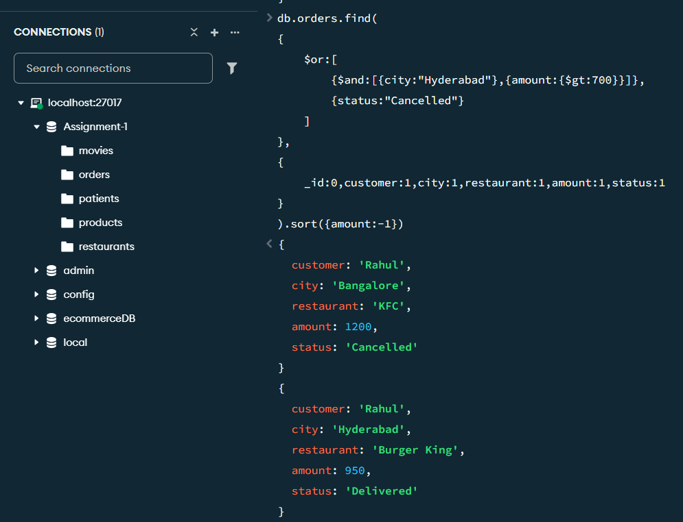

Scenario 2 — Order Items Verification & Tagging
Topics: Element Operators ($exists, $type), Update Documents ($set)
Confirm using $exists and $type that every order document has a status field stored as a string. Then add an items array field to each order using $set, listing 2–3 food items that plausibly match the restaurant (e.g., a Paradise order might include "Chicken Biryani" and "Raita").
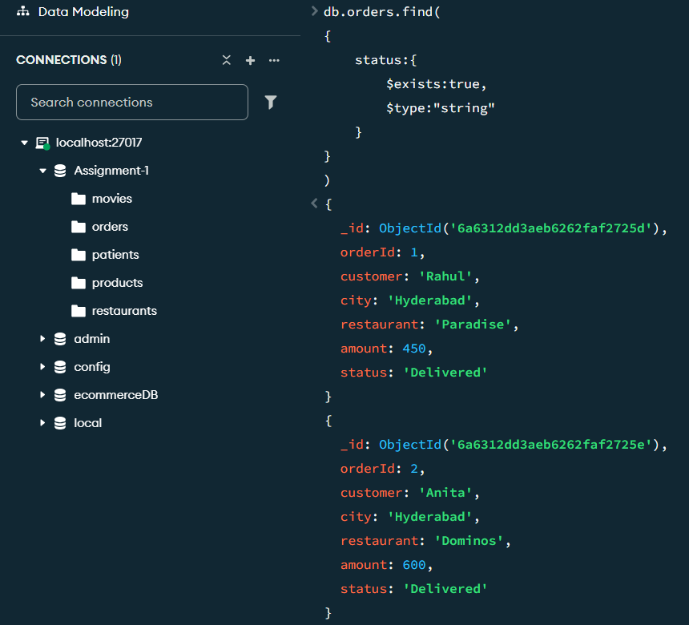
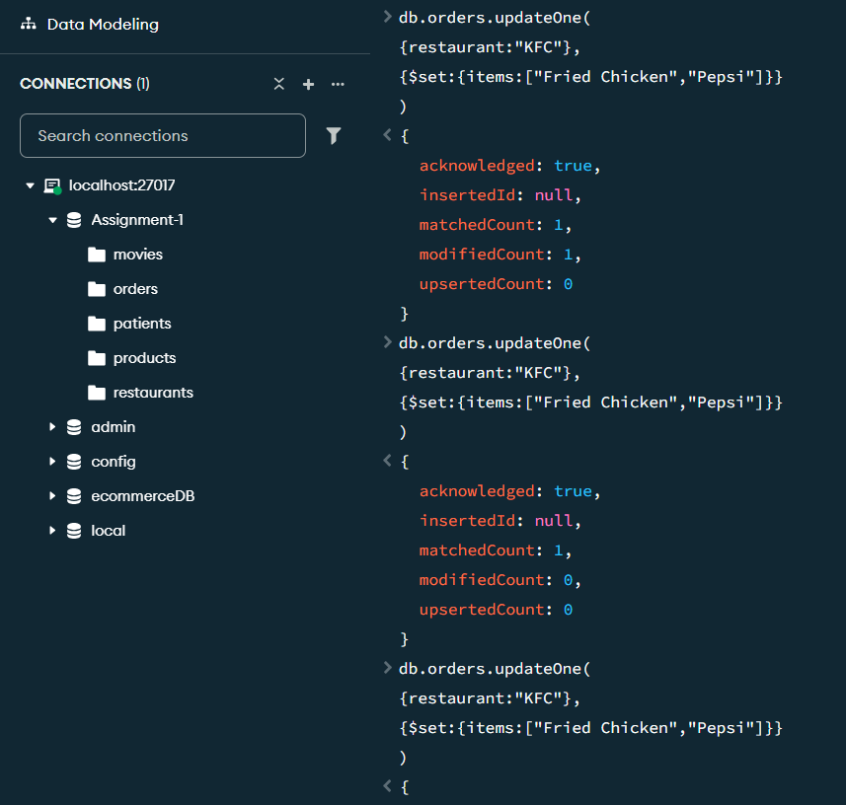
Scenario 3 — Purge Unfulfilled Low-Value Orders + Service Fee
Topics: Logical Operators ($nor), Delete Documents, Update Documents ($mul)
Operations wants to purge orders that are neither delivered NOR high-value (amount > ₹1,000), using $nor — these represent stalled, low-value orders unlikely to be worth tracking. Find and delete them. Then apply a 5% service fee to every remaining Delivered order using $mul.

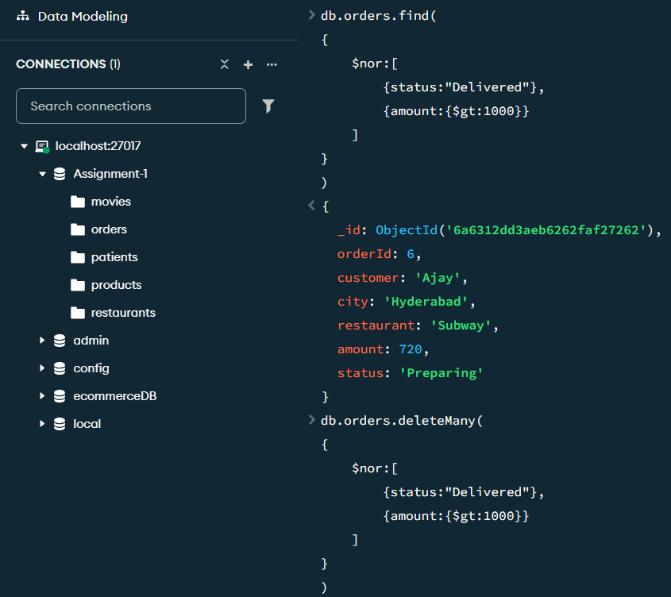
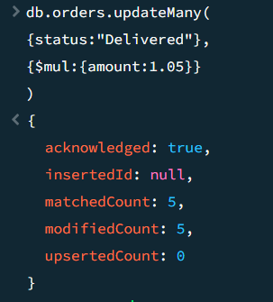

Scenario 4 — Item-Based Order Search
Topics: Reading Arrays (array element match), Logical Operators
Using the items array from Scenario 2, and working only against the orders that survived the Scenario 3 cleanup, find every Delivered order whose items array contains "Fries".
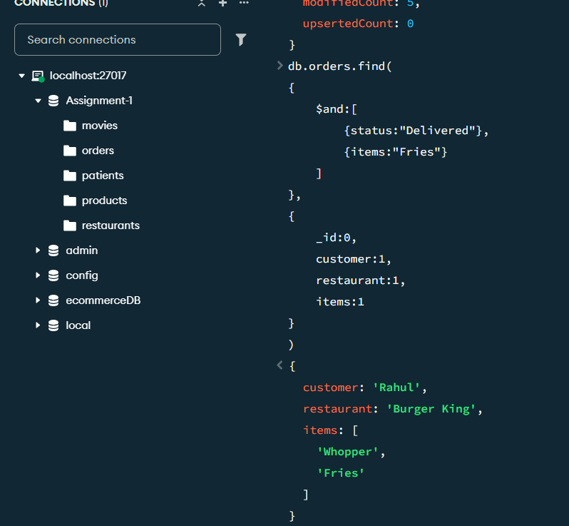

Scenario 5 — Menu Updates & Add-on Services
Topics: Updating Arrays ($push, $each, $pull, $addToSet)
Add two dessert options, "Brownie" and "Ice Cream", using $push with $each to the items array of the two highest-value remaining orders. Burger King is discontinuing a menu item — use $pull to remove "Fries" from Rahul's Burger King order. Finally, add a services array field to every remaining order using $addToSet containing "Gift Wrap", written so a repeated update never creates a duplicate


